**Database Management and Design Final Project**

First I created dimensional data sub-models with the help of the given Data model for Warehouse Schools K12 DW namely Absences, Discipline Behavior, Academic Performance and Special Programs by doing reverse engineering process in Toad Data Modeler. After that, using Management Studio SQL I have analyzed some generalized queries in the perspectives of a Parent, a Teacher and a School Administrator. I created OLAP cubes by using Microsoft Visual Studio for each of the four dimensional data models. Then I wrote SQL queries for each of the models in each of the three perspectives for Business Intelligence and analysis. Performed BI analysis using PoIr BI tool. Created Databases in MySQL and Oracle from MSSQL School_K12_DW and performed querying and analysis.

**Performed reverse engineering in TOAD Modeler on SQL server School_K12_DW to build sub-models for**

1. Absences
2. Discipline Behavior
3. Academic Performance
4. Special Programs

Tools used: Toad Modeler

**Created a description & listed sample types of analysis/queries for each data subset from the following perspec**

1. School Administrator
2. Teacher
3. Parent

Tools used: SQL server management studio, MSSQL Database Server

**Created OLAP (SSAS) cube for each data model:**

1. Absences
2. Discipline Behavior
3. Academic Performance
4. Special Programs

Tools used: MS Visual Studio, SQL server management studio, MSSQL Analysis Server

Steps Performed: -

1.Created the data source from OLAP cube built for each sub-data model

2.Created data source views.

3.Created Dimensions in Multidimensional Models

(Added extra measures in respective cubes such as average grades, count of total students)

4.Created Measures and Measure Groups in Multidimensional Model

5.Deployed the cube successfully.

**Performed BI analysis referring the queries written in SQL server for each cube in the perspective of parent. School admin and teacher.**

Tools Used: PoIr BI

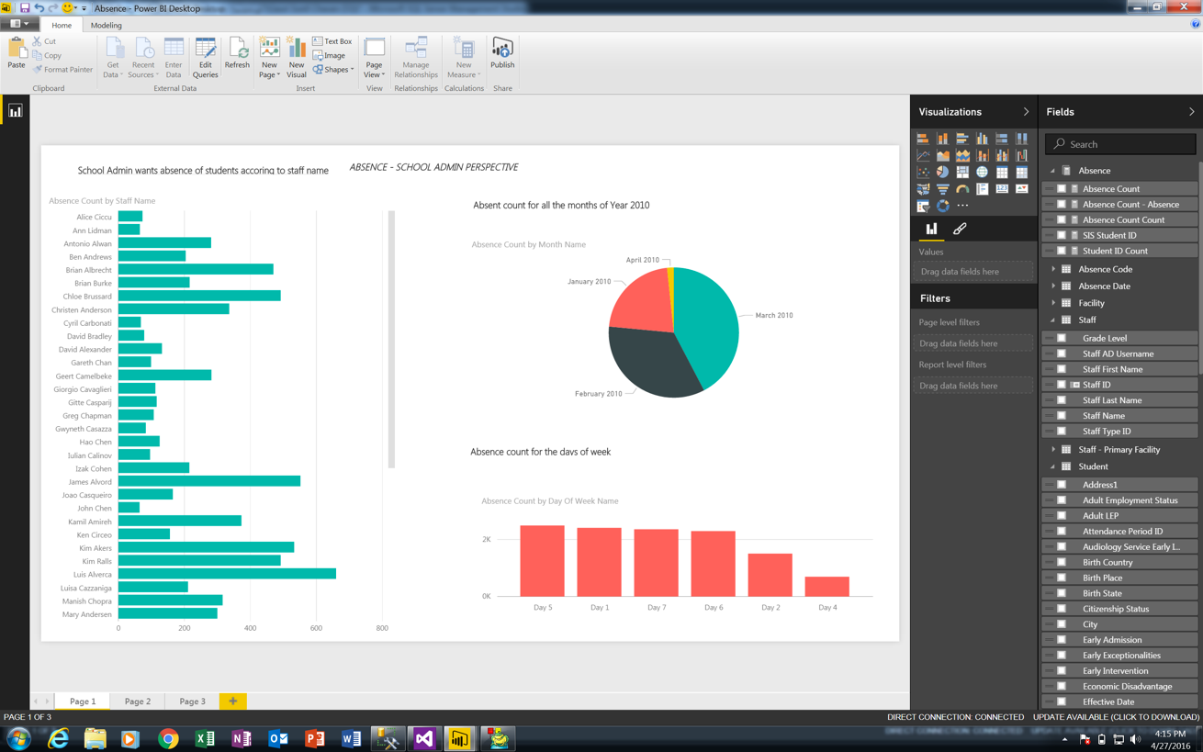

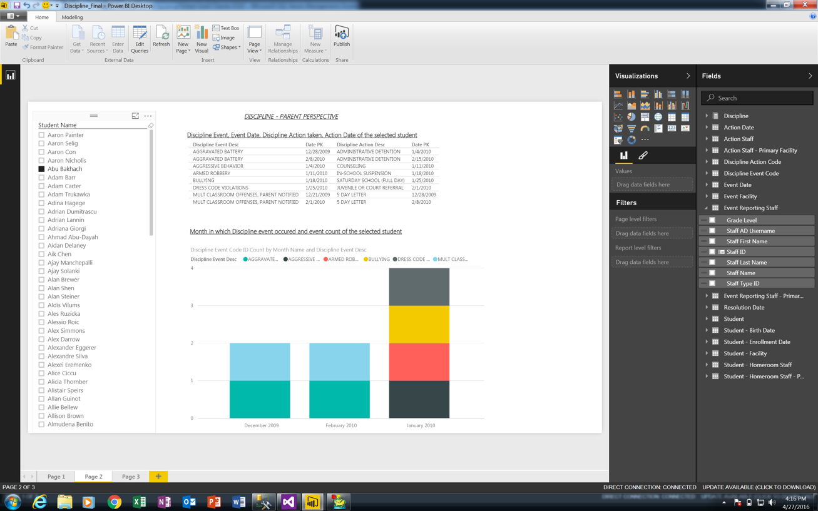

**Creating Databases in MySQL and Oracle: -**

Steps: -

1. Performed reverse engineering on MSSQL School_K12_DW and generated a ddl script compatible for MySQL database

2.Run the ddl script in MySQL database and created the database schema.

1)Creating table

2)Updating table and inserting foreign key constraints

3.Exported the data in each dimension and fact table to a flat file in a CSV format.

4.Using a tool called RAZOR SQL, connected to MySQL server instance on the local host.

5.Using the same tool imported the data in each table from respective flat files.

6.First loaded all dimensional tables and then all fact tables following referential integrity rules.

Note: date attribute is handled differently in every database. So I formatted the date columns in ‘mm/dd/yyyy’ format and then set the format in every db to same.

Note: Same steps are performed for Oracle except there is inbuilt tool in oracle to import data from flat files.